**HALLS HEAD CROQUET CLUB NEWSLETTER JULY 2024**

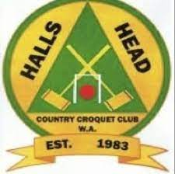

**SAUSAGE SIZZLE Saturday 15th June**

**A monumental effort members, and a big thank you from us all.**

**Dave Hedges and his team raised over $1200 for club funds**

**The team** Dave Hedges, Jo Waddell, Jan Cameron, Bernie Lynch, Mary Whiteley, Tricia Collinson, Lyn Bermingham (plus daughter, Tina), Brian Audas, Terry Kerrigan, Carol McKinley, Hazel Self, Vicky Spitz, Katrina Johnston. What a team !

Our monthly lunch in June was held at Nourish the Soul on the Waterfront of the Canals on Darwin Terrace. It’s always a favourite venue. Jo, Brian, Mary, Sheila and Lyn tucked in to curries or toasties plus a glass or two of red.

Watch out for the next lunch – the list will be on the club house table next week.

Alcoa heroes are to come and work their magic at our club this month, painting and de-rusting, so that we don’t have to climb ladders ! Many thanks to Jo.

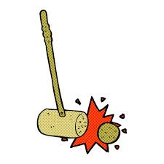

**Any item for your newsletter** ? Send to Sheila.twine@bigpond.com

**SOUTHERN HUB CROQUET TOURNAMENT**

**This was designed to encourage new players to enter their first tournament (or even their second) 5 Clubs took part, Halls Head, Mandurah and the new clubs Byford Districts, Drakesbrook Waroona, and Pinjarra**

The inaugural torrnament was held at Halls Head, (left photo). On Sunday 25th June it was hosted by Byford Districts who set up four courts for the 32 entrants. (Photo on the right). MLA Hugh Jones and Serpentine Jarrahdale Shire President Rod Coales both attended

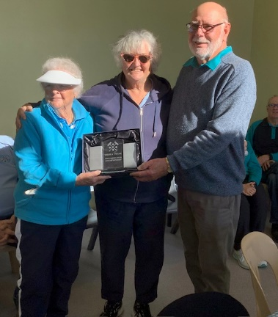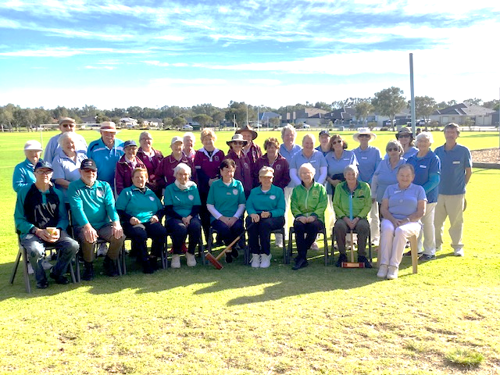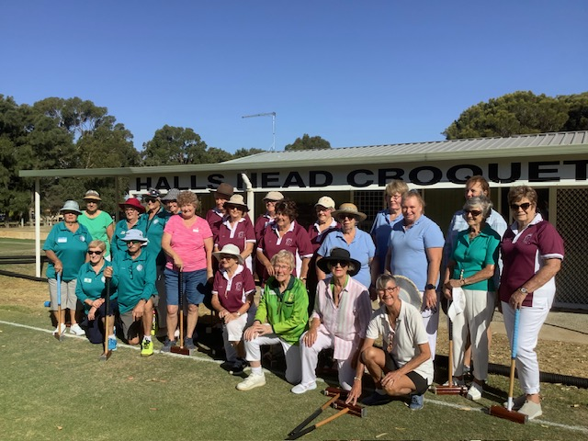Winners of the club tournament went to Drakesbrook in the inaugural tournament and Mandurah this June 2024. **Well done to Mandurah**. The O’Shaugnessy and Storey teams. The new perpetual trophy was donated by Drakesbrook and called the ‘Sheila Twine, Southern Hub perpetual trophy’ presented by Andrew Johnston.

The individual winner was Liz Nicholas from Pinjarra, Byford member Phil Davey won the Hooping contest and Hazel Self from Halls Head won a spot prize for the best long hoop approach.

In 2025 Pinjarra will host this Southern Hub tournament at their new grounds at South Yunderup where there is space for four or even five courts. So watch out for that and come along to enjoy the fun in a stressless tournament.

**DIARY NOTES**

**GC C GRADE DOUBLES STATE CHAMPIONSHIP is being hosted BY HALLS HEAD AND MANDURAH** (depending on numbers of entries)on **MONDAY AND TUESDAY 20TH 21ST JULY.** This is a really good opportunity for all our C and D grade members with handicaps of 10 to 14 or 20. Don’t be shy. This is for you and is being hosted on our courts, so no traveling involved. Flyer will be out this week. Let’s have a good number of entries from Halls Head.